While filling out the form

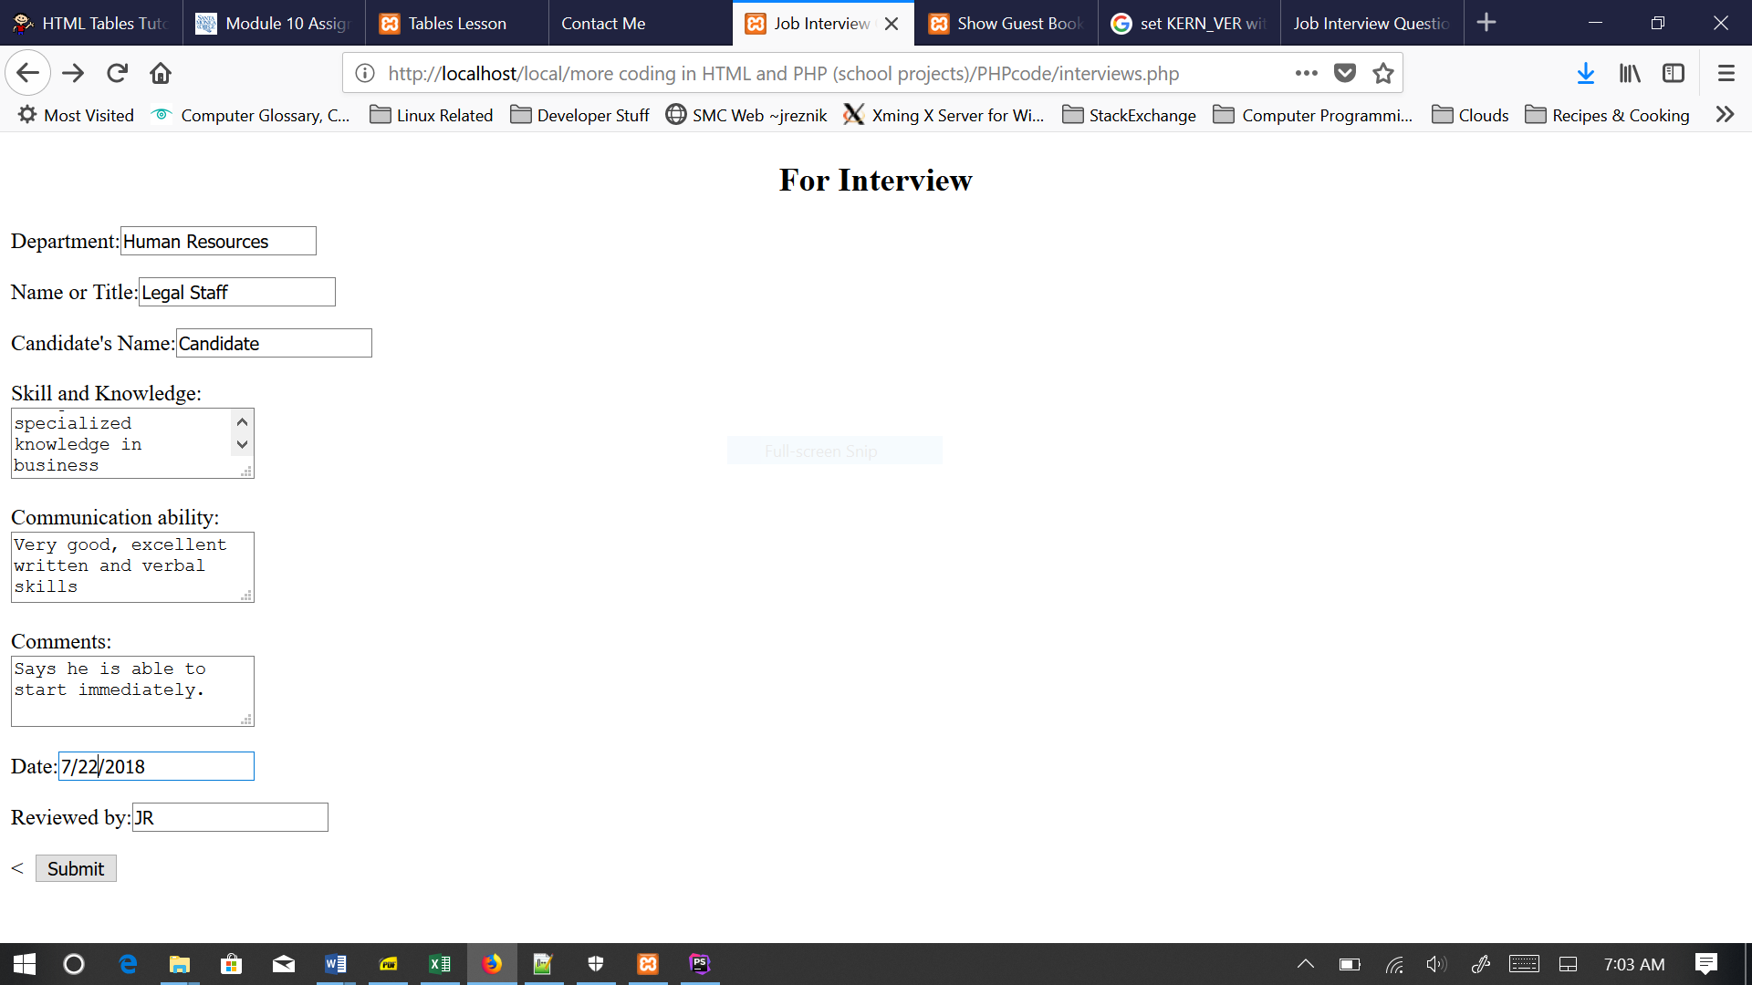

And with proper results displayed (more or less, variable data types possibly in question)

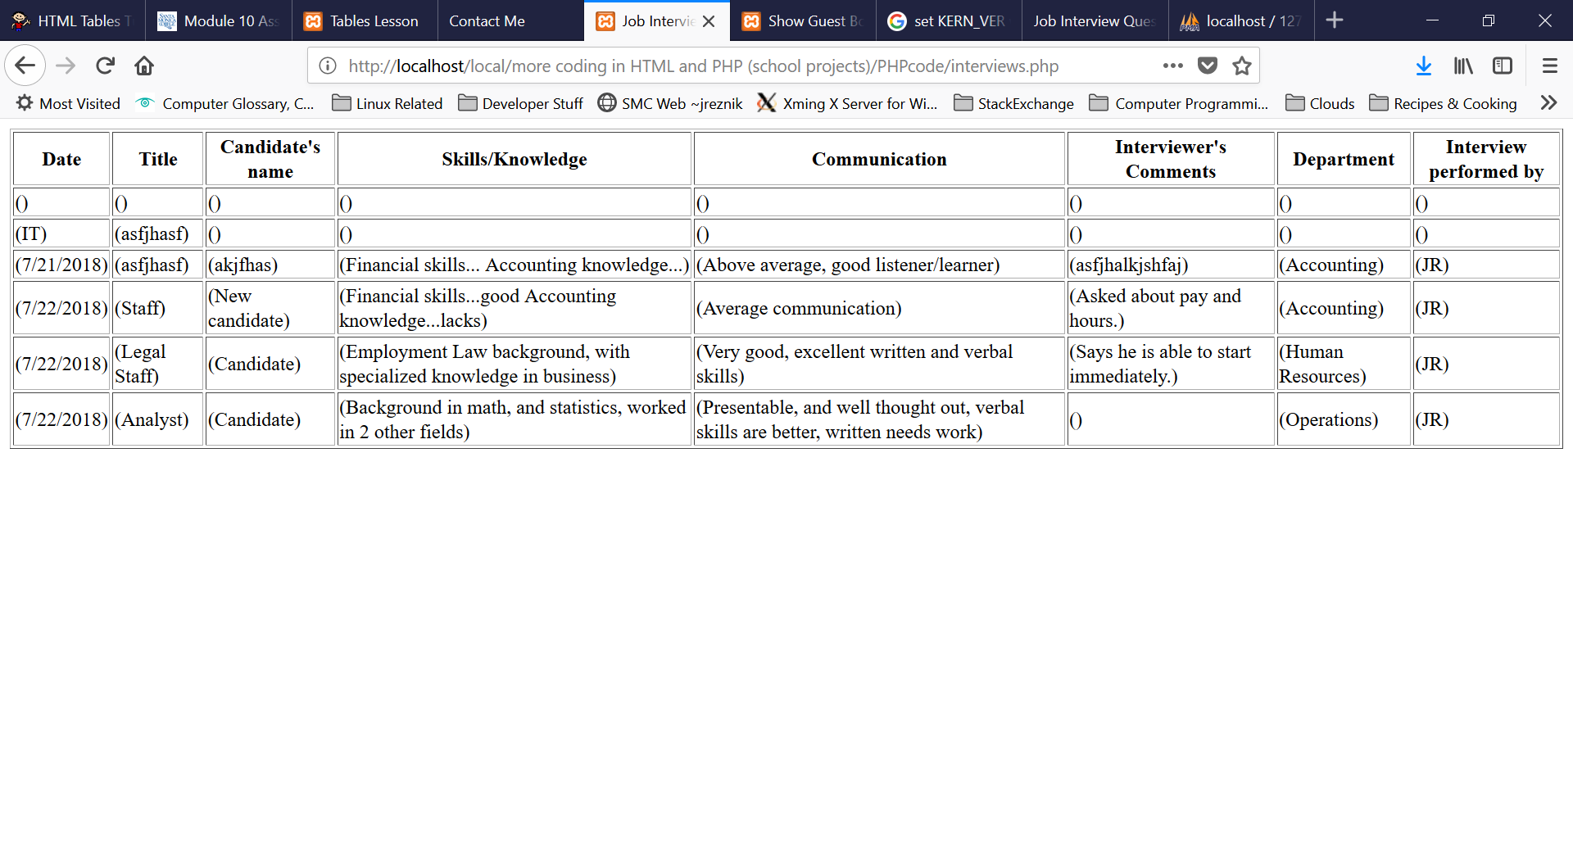

One more view from the web browser SQL admin page showing interview database

